**Allegro**

**Added on April 26, 2018.**

1. To register an account with SandBox, you need to follow the link <https://apps.developer.allegro.pl.allegrosandbox.pl/>,   
to register Live - by link <https://apps.developer.allegro.pl/>,   
and fill in the necessary data.

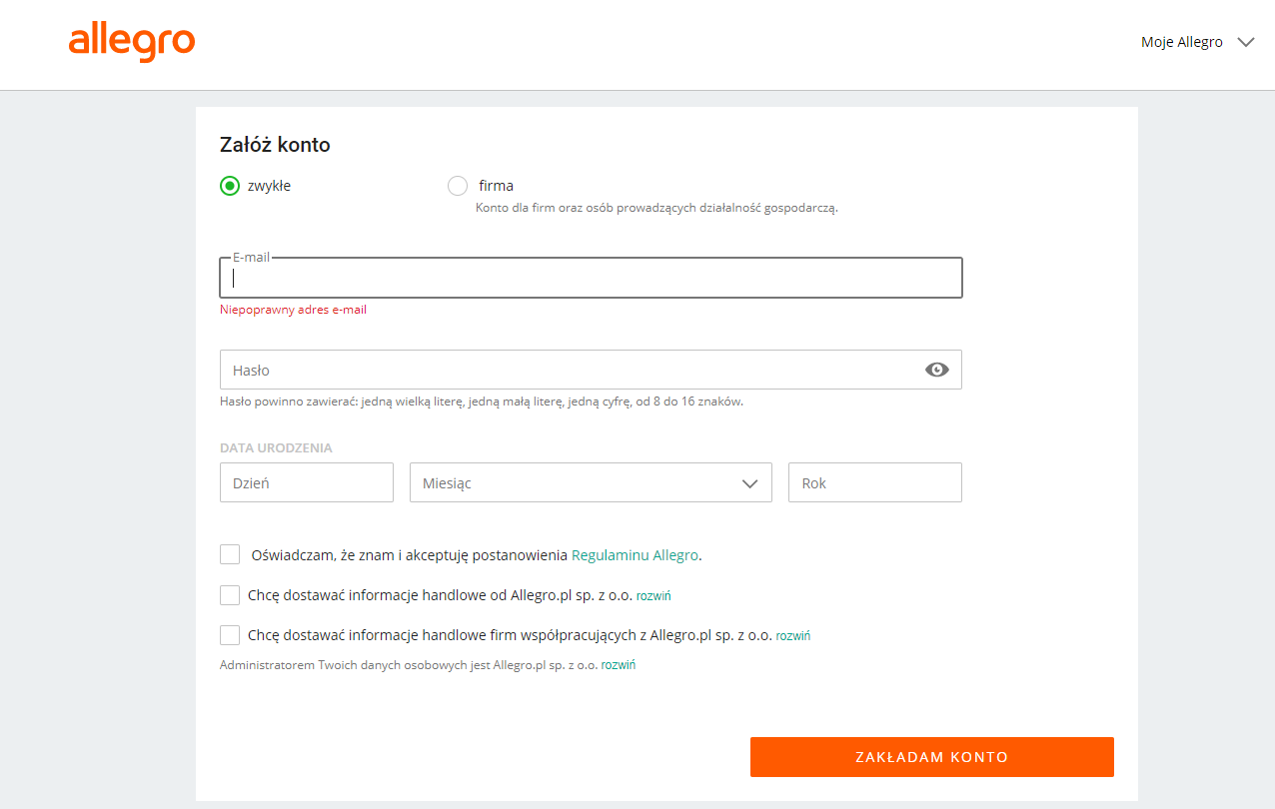

2. Confirm registration via e-mail.

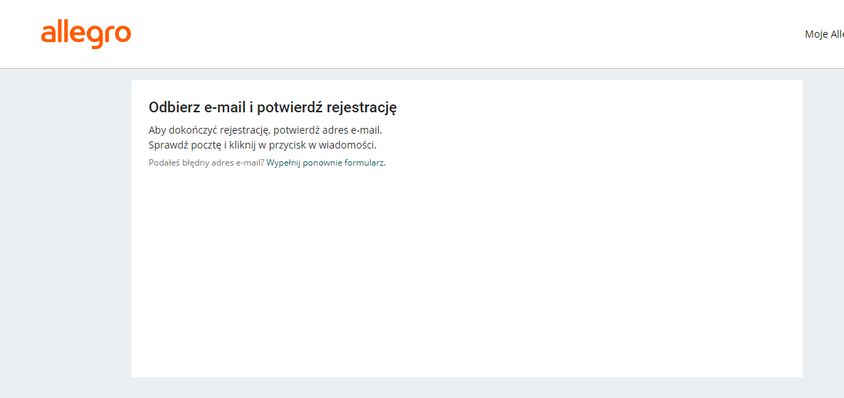

3. To register an application in SandBox, follow the link <https://apps.developer.allegro.pl.allegrosandbox.pl/>,

To register for a Live application, please follow the link <https://apps.developer.allegro.pl/>.

.

4. Click on the button "Register a new application".

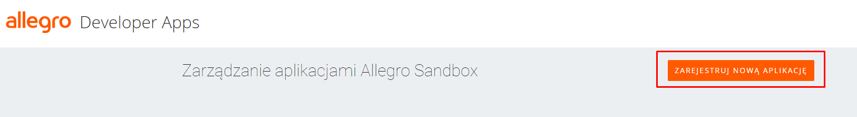

5. Then fill in the description of the application and the redirect URL for authorization and click on the add button.

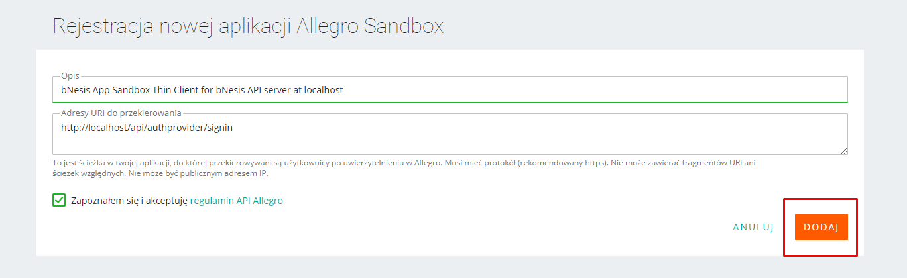

6. In the window that opens, you can obtain the necessary data for authorizing and using the service API.

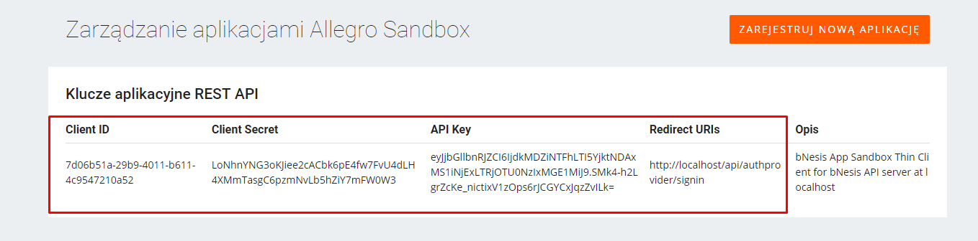

**Live**

1. To register an account with Live, you need to follow the link <https://apps.developer.allegro.pl/>   
and fill in the necessary data.



2. Confirm registration via e-mail.



3. To register the application, follow the link <https://apps.developer.allegro.pl.allegrosandbox.pl/> .

4. Click on the button "Register a new application".



5. Then fill in the description of the application and the redirect URL for authorization and click on the add button.



6. In the window that opens, you can obtain the necessary data for authorizing and using the service API.

